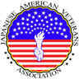
Japanese American Veterans Association
Maryland House of Delegates Presents Resolution to Nisei WW II Veterans
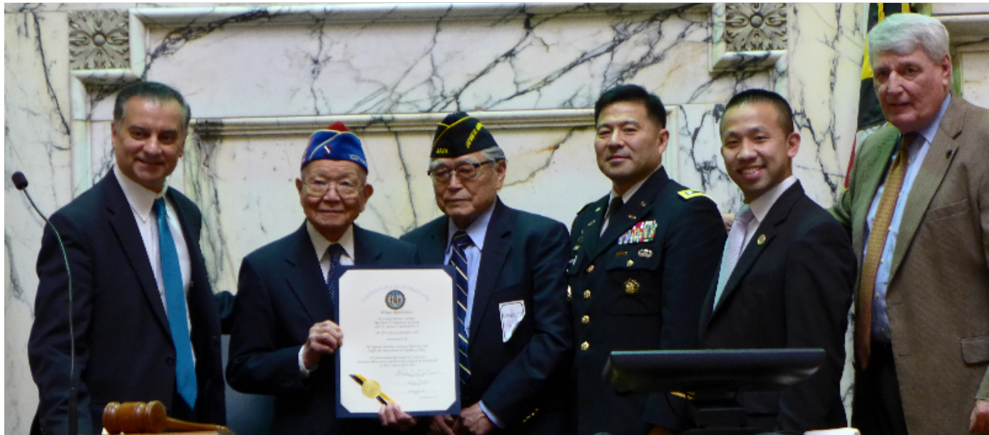
In a precedent-setting ceremony, Maryland House of Delegates presented a Resolution to the 100th Battalion, 442nd Regimental Combat Team, and the MIS on April 1, 2016, on the floor of the Maryland House of Delegates at Annapolis, MD. This photo was taken after the presentation of the Resolution. L-R: Kumar Barve, Member of the Maryland House of Delegates representing Montgomery County; Terry Shima JAVA and 442nd; Dr Ray Murakami, JAVA and Linguist, Occupation of Japan; LTC Mark Nakagawa, USA (Ret), Vice President of JAVA; Delegate Clarence K. Lam, M.D.; and Michael E. Busch, Speaker of the House of Delegates.

Prior to the presentation, Delegate Lam testified to the House of Delegates members the Japanese American experience during WW II. The Maryland House of Delegates Resolution# 134 said “Be it hereby known to all that the House of Delegates of Maryland offers its sincerest congratulations to the 100th Infantry Battalion, 442nd in recognition of the Japanese American veterans of these units who fought the enemy abroad and prejudice at home. The entire membership extends best wishes on this memorable occasion and directs this resolution to be presented on this 1st day of April, 2016. Signed: Michael E. Busch, Speaker of the House and Sylvia Siegret, Chief Clerk.” Photo from LTC Nakagawa.

Maryland State Senate Presents Resolution to Nisei. Nisei Invited to Speak
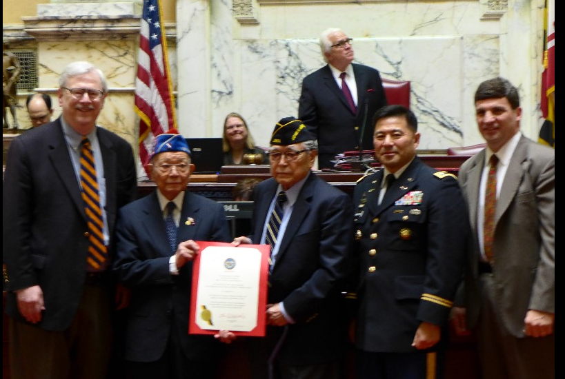
Following the presentation of the Resolution in the Maryland House of Delegates chamber on April 1, 2016, JAVA representatives were invited across the hall to the Maryland Senate Chamber of the State House. It was said this is the first time an Asian Pacific American military unit was honored in this history-laden chamber. Senator Thomas Mike Miller, Jr., President of the Senate welcomed the JAVA delegation and Senator James Rosapepe, spoke about the Nisei experience during WW II. This was followed by the presentation of the Resolution to Dr. Ray Murakami and Terry Shima. On the invitation of President Miller to speak, Shima addressed the Maryland Senate. He told the 47 senators,
“On behalf of 100th Battalion, 442nd Regimental Combat Team, the Military Intelligence
Service, the 110,000 persons of Japanese Ancestry who were confined in internment
camps for the duration of WWII, the 800 we left on the battlefields of Europe and
the Pacific, and the Japanese American Veterans Association, I wish to thank the State
of Maryland for this extraordinary recognition. It is a great honor to receive this
Resolution in the Senate Chamber that served as the US Congress from November
1783 – August 1784, where General George Washington resigned his commission
as commander in chief of the Continental Army on December 23, 1783, and where
the US Congress ratified the Treaty of Paris on January 14, 1784 that officially ended
the Revolutionary War thus making Annapolis the first peace time capital of America.
We are proud to be contributing citizens to the Greatness of Maryland and America.
God Bless Maryland and the USA.”

